**Lab 7: ICMP**

University of Windsor

Department of Electrical and Computer Engineering

ELEC 8560 – Computer Networks

Semester: Fall 2023

**Student Name**: Amey Mahendra Thakur

**Student number**: 110107589

**Answers:**

1. The host's IP is **192.168.2.20**, and its destination is **142.251.41.36.**

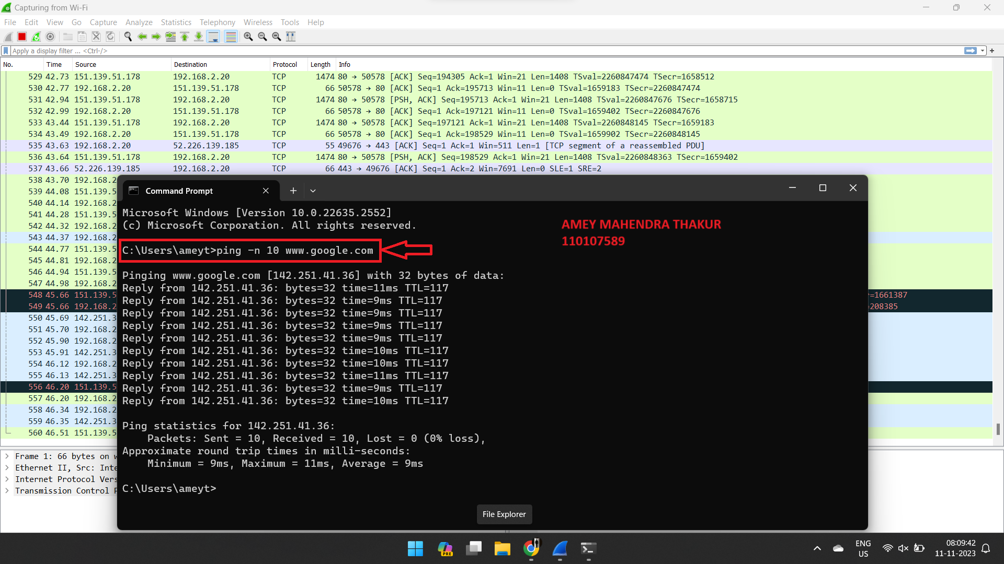

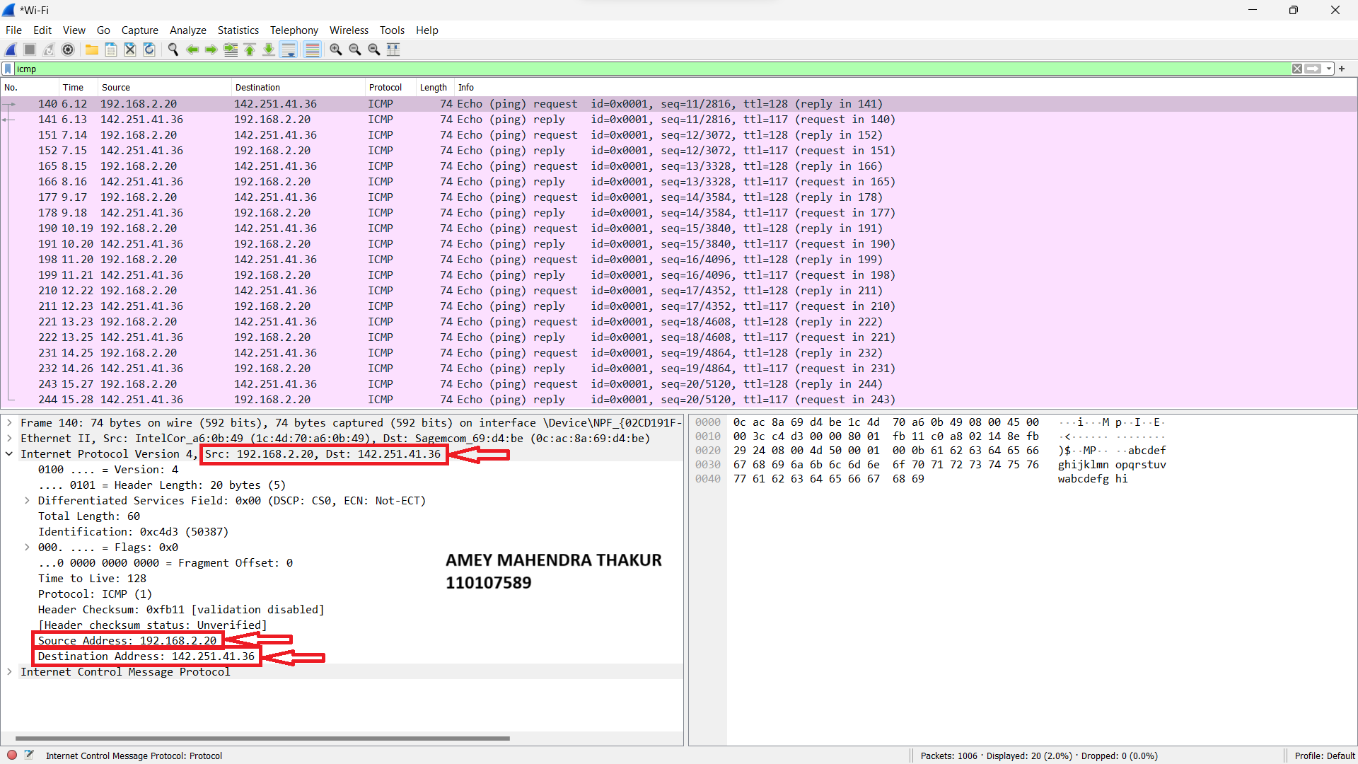

1. The ICMP packet specifies Type 8 and Code 0, accompanied by specific fields for checksum, checksum status, Identifier (BE), Identifier (LE), Sequence number (BE), and Sequence number (LE), with each field occupying 2 bytes.

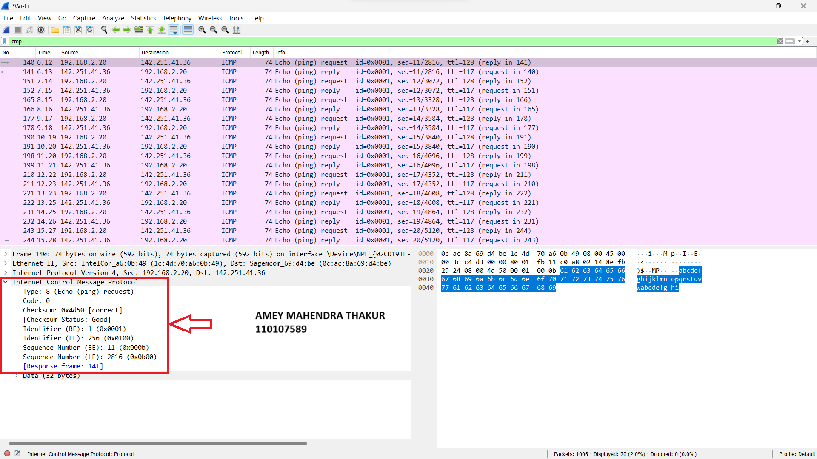

1. The ICMP packet includes Type 0 and Code 0, alongside fields for checksum, checksum status, Identifier (BE), Identifier (LE), Sequence number (BE), and Sequence number (LE), each field being 2 bytes in size.

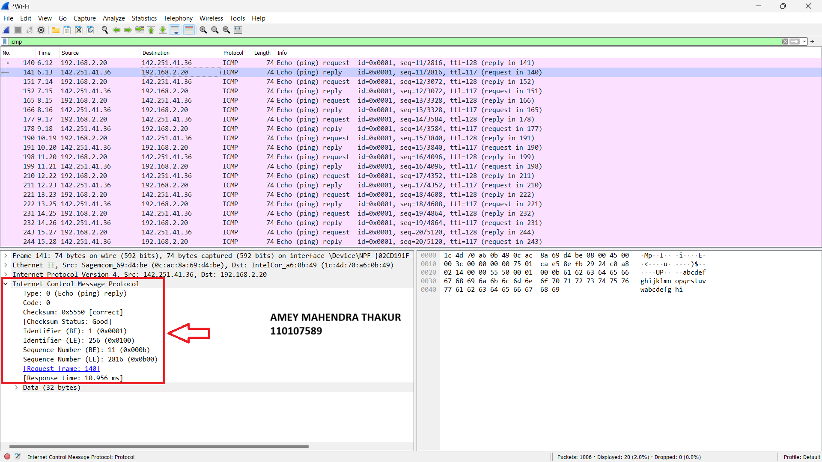

1. My host's IP address is **192.168.2.20**, and the destination host's IP address is **172.217.1.4.**

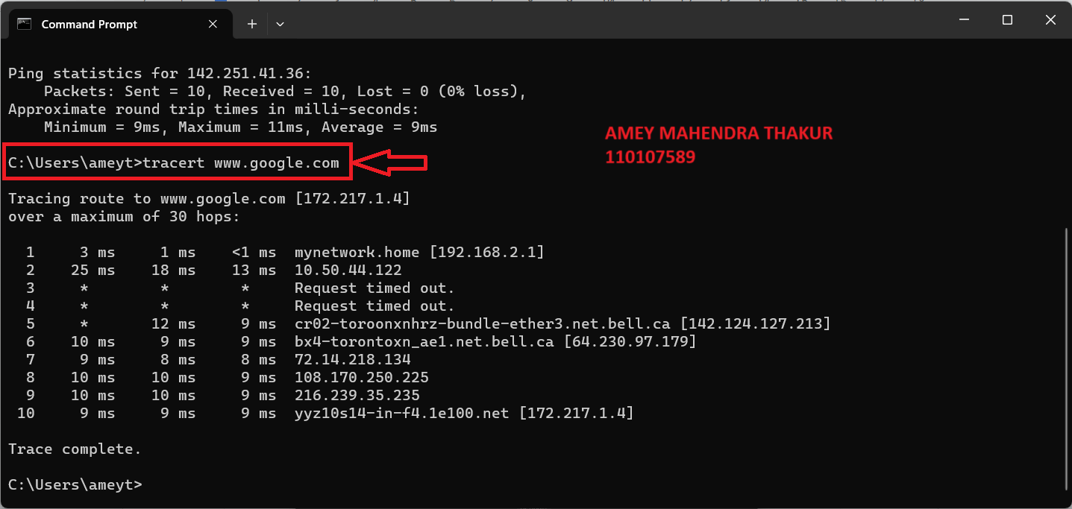

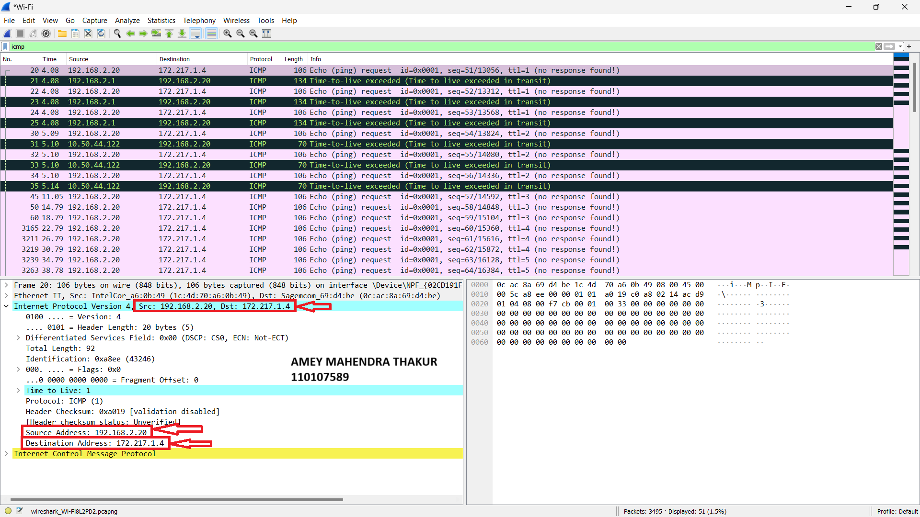

1. If ICMP were to transmit UDP packets instead, the IP protocol number wouldn't be 01 but 0x11.
2. The ICMP echo packet and the ICMP ping query packet share the same fields.

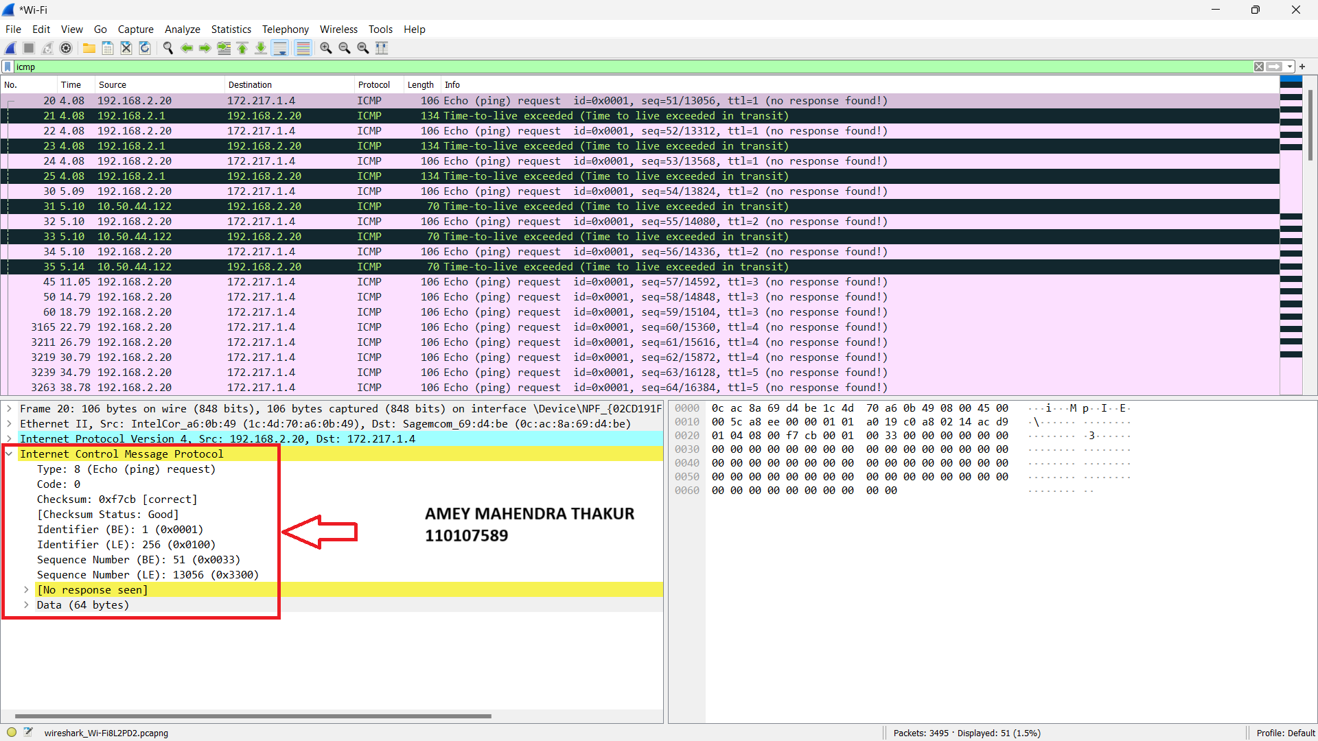



1. The ICMP error packet comprises the header and the initial 8 bytes of the ICMP error packet, alongside IPV4 fields within the error packet.

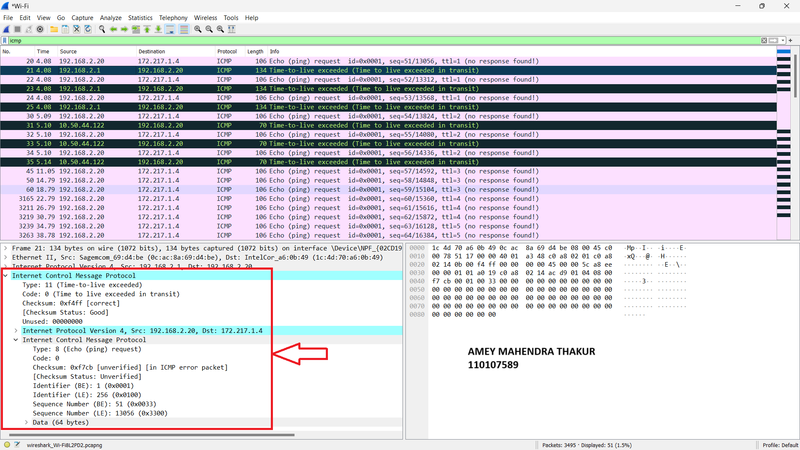

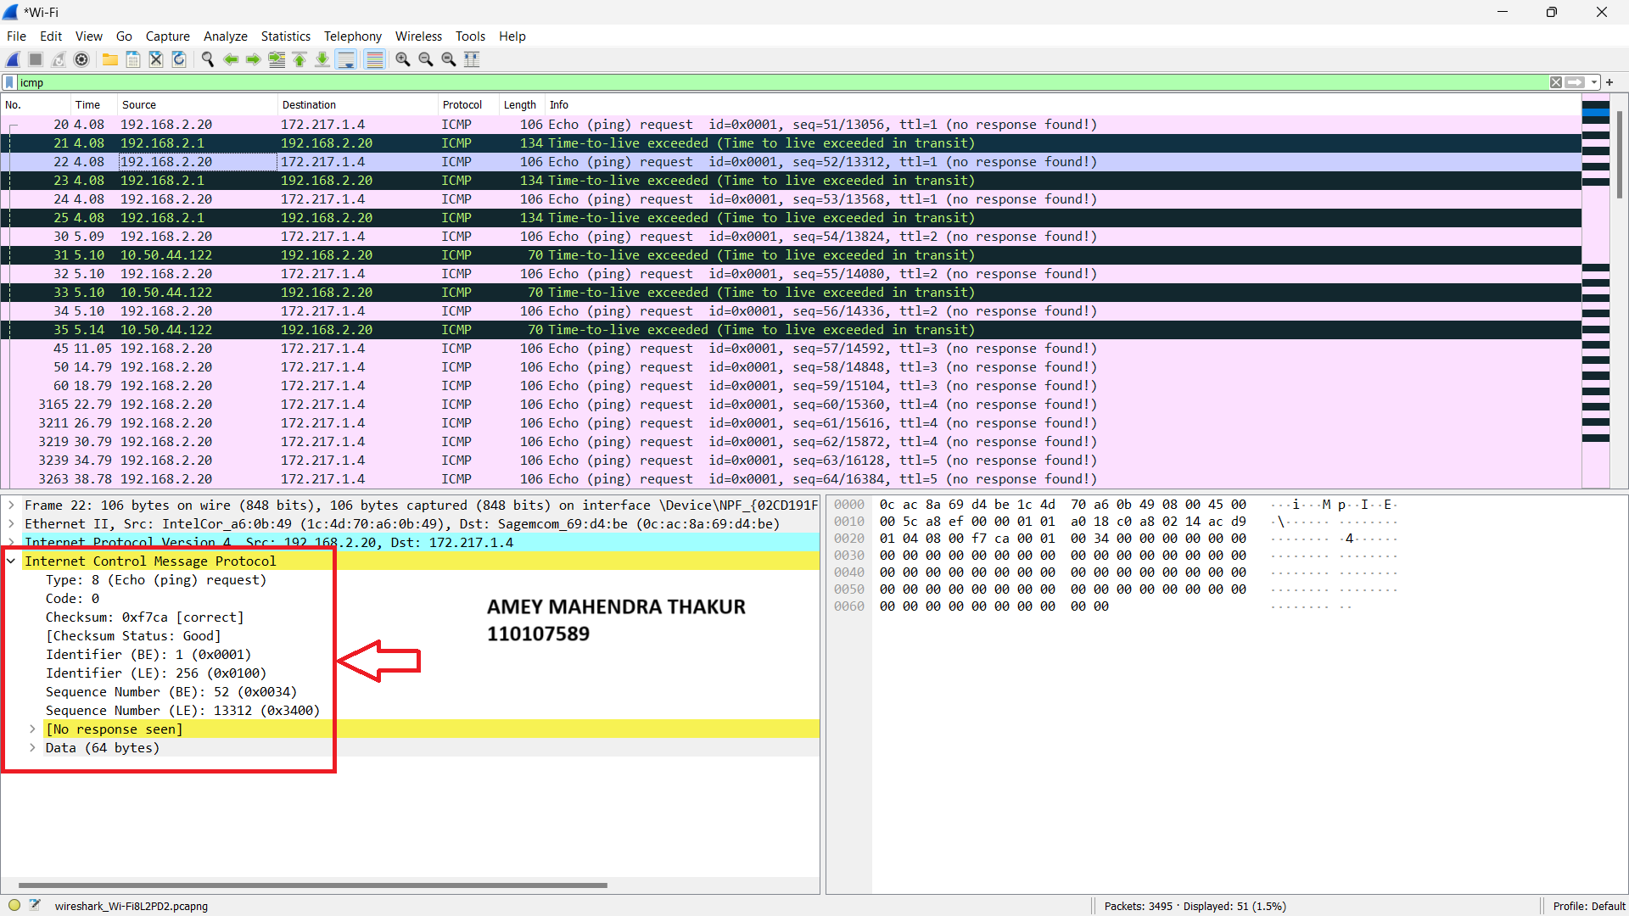

1. Error packets have a **"type" field of 11**, while the last three replies have a **"type" field of 0.** This distinction arises from the datagrams reaching the destination **before the TTL expiration.**

